Isotopes and Mass Spectrometry

- a) What is the average atomic mass of copper on the periodic table?

b) Is it closer to 63 amu or 65 amu?

- Consider the data given in the table below. Determine the average mass of an element based on data table the isotopic abundance and the mass of each isotope

Isotope | % Abundance
²⁰Ne | 90.48
²¹Ne | 0.27
²²Ne | 9.25

- There are two stable isotopes of calcium: Ca - 40 (39.96) and Ca - 46 (45.95). Using the average atomic mass of calcium from the periodic table, calculate the % abundance of each isotope of calcium.

Model 2: Mass spectrometry

Information:

Mass Spectrometry is a powerful analytical tool used to determine the following information.
- The elemental composition of a sample
- The masses of particles and of molecules
- Potential chemical structures of molecules by analyzing the fragments
- The identity of unknown compounds by determining mass and matching to known
spectra
- The isotopic composition of elements in a sample

A mass spectrometer is a device for separating atoms and molecules according to their mass.
In a mass spectrometer, a substance is first heated in a vacuum and then ionized. The ions produced are accelerated through a magnetic field that separates ions of different masses. The height of each peak is proportional to the amount of each isotope present (i.e. it’s relative abundance). The m/z ratio for each peak is found from the accelerating voltage for each peak. Many ions have a +1 charge so that the m/z ratio is numerically equal to mass m of the ion.

The graph below was produced when an element, lithium, was analyzed in a mass spectrometer. Use the graph to answer the questions below.

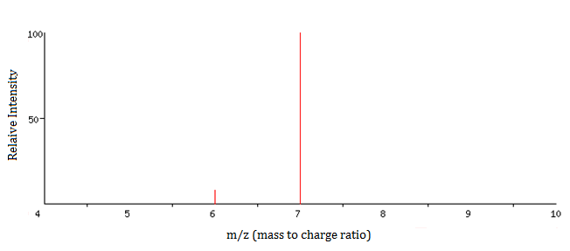
Isotope mass Rel. Intensity
6 amu 8
7 amu 100
Mass spectrum of Lithium

- How many isotopes of Lithium exist?

- What masses are present on the graph for the following

a) The mass of the most abundant isotope

b) The mass of the least abundant isotope.

- Label the each peak with the nuclide symbol for each isotope

- Without performing any calculations, predict the approximate atomic mass for lithium. Explain the basis for your prediction.

- Now calculate the average atomic mass of the element from the mass spectrum data. The height of each peak is the relative intensity, not the % abundance. You will first need to calculate the % abundance and then the average atomic mass.

a) What is the relative intensity of each peak?

Peak 1 = ____________

Peak 2 = ____________

b) What is the total relative intensity of the peaks?
Total = __________

c) What is the % of the intensity of each peak? ($\%= \frac{Part}{Total} x 100$)
Peak 1% = __________

Peak 2% = __________

d) You’ve just determined the % abundance for each isotope of the element. Complete the table and calculate the average atomic mass of the element.

Isotope | Mass | % Abundance

Average atomic mass = __________amu

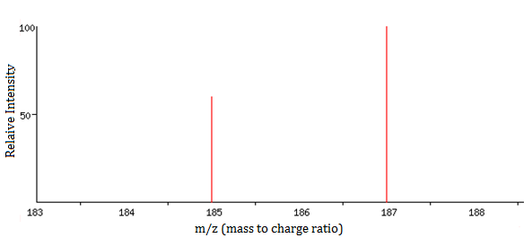
- What element’s mass spectrum is represented below? Explain your answer.
- a) What is the average atomic mass of Boron?

b) If there are two predominant isotopes of Boron on earth, ¹⁰B and ¹¹B, which do you think is most abundant?

c) Make an estimate of the percentage of each isotope of Boron.

d) Draw a rough sketch for the mass spectrum of Boron. Label each axis and label each peak with the appropriate nuclide symbol

- There are two naturally occurring isotopes of rubidium, ⁸⁵Rb and ⁸⁷Rb. Use the process above to draw a rough sketch for the mass spectrum of rubidium.

Exercises

- The mass spectrum for elemental bromine is represented below. Label each peak with the appropriate nuclide symbols. Remember, not all elements exist as single atoms in nature.
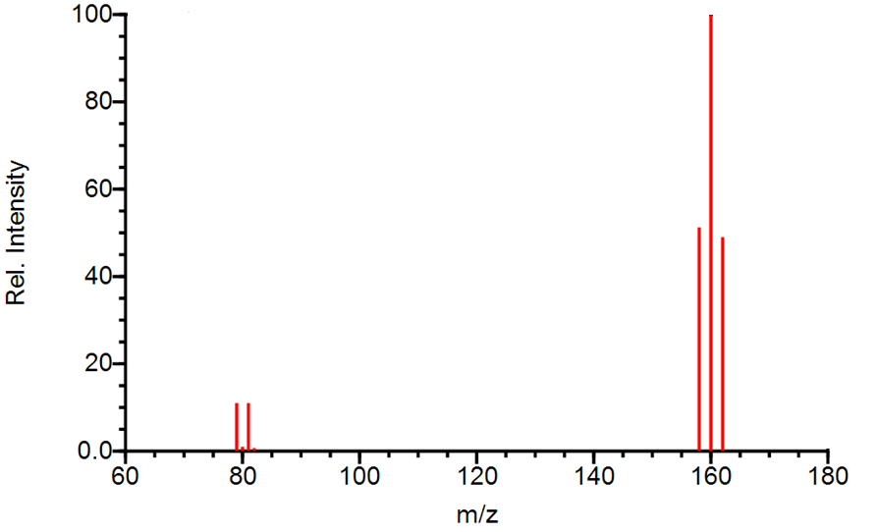

- The mass spectrum of strontium gives four peaks. Use the data below to answer the following questions:

m/z | 84 | 86 | 87 | 88
Relative intensity | 0.68 | 11.94 | 8.48 | 100.00

a) Sketch the mass spectrum that would be obtained from naturally occurring strontium.

b) Label each peak on the mass spectrum with the appropriate nuclide symbols.

c) Calculate the average atomic mass of strontium in the sample rounded to two decimal places.

