Energy Profiles
1. For each reaction below:
- Endo or exo? • ΔH reverse reaction?
- Ea forward? • Relative heat of products?
- Ea reverse? • Relative heat of activated complex?
- ΔH forward? • Relative heat of reactants?
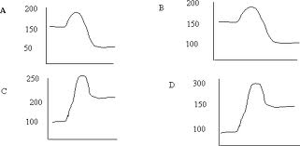
2. For the following reaction:
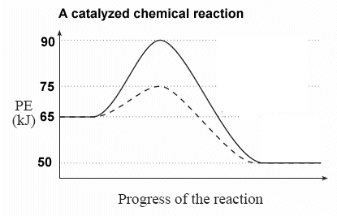
- Ea of the uncatalyzed reaction?
- Ea of the catalyzed reaction?
- Ea of the catalyzed reverse reaction?
- ΔH of the uncatalyzed reaction?
- ΔH of the catalyzed reverse reaction?

